### Background Of The Project

As of this time, the loan process being implemented by Infrastructure Development Company Limited (IDCOL) and Bangladesh Infrastructure Finance Fund Limited (BIFL) - the Implementing Financial Institutions (IFIs) relies on a series of manual, and unorganized steps.

In our CSE 303 Database Management System course, we have been tasked with analysing the complete business model, critique it, and based on our observations develop an Automated Loan Processing and Monitoring System. The system proposed will have to take full advantage of automation, sustainability and usability by organizing the loan management process into a more organized, systematic, logical, procedural, and sound manner. It software will also enable the stakeholders to monitor and record the progress of their process in the organization. It will enable the organization to have more confidence over its data by storing information regarding the progression, reports, eligibility conformities, etc more accurately and efficiently than as the current model. [No critical and sensitive information will be saved locally so as to avoid ] The amount of work on part of the Financial Institusions im carrying out the loan process manually is very cost expensive, as there can be discrepency at any stage of a quite large process. Thus preventing them from closing the loans by the agreed-upon due date. The automated system proposed, having magnified down to all the drawbacks, will provide a higher efficiency and automization, reducing manual and cumbersome tasks, and overall, lower the costs of the organization greatly.

Our software is finely tailored to suit the requirements of our clients - the proponents, Implementing financial institutions (IFI), Sustainable and Renewable Energy Development Authority (SREDA), Participating distributor (PD), Japan International Cooperation Agency (JICA) and also Ministry of Power,Energy and Mineral Resources (MPEMR). The business model of the overall organization sums up to these major work blocks:

[Insert Rich Pic Here]

Proponent REQUESTS FOR Loan

TO

IFI

IFI

SENDS PROCESSED REQUEST

TO

SREDA

SREDA

DECIDES TO APPROVE OR DISAPPROVE

SENDS RESULT TO IFI

IFI PROVIDES Loan

SREDA

MONITORS Project Proponent after receiving the loan.

[INSERT BENIFITS OF SOFTWARE HERE]

There are two loans for extending the EE&C promotion financing loan, which are:

(a) A-type loan: IFIs lend money directly to the companies and organizations who are introducing the EE&C equipment, and;

(b) B-type loan: There is an intermediary distribution organization called “participating distributors (PDs)” who supply EE&C equipment (home appliances).

**Background Of The Project**

With the rapidly depleting natural resources, and deteriorating environmental changes, the search for a greener, more sustainable path to growth has been more dire than ever. One of the findings that came up is the Energy Efficiency & conservation (EE&C) Promotion Financing Project. It has been built upon the sole purpose of achieving more longlasting greener development of Bangladesh using state of the

art quality assured EE&C materials. This is expected to bring down carbon and other greenhouse gas emissions by a drastic X___ Insert Value here ___ %, keeping in par with the demand and supply in the economy. In the December of 2015, in response to Bangladesh’s seventh five-year plan. The Japanese Government (represented by JICA), extended the concessional loan (11.5 billion JPY) to the Government of Bangladesh (represented by Finance Division, Ministry of Finance) with an interest rate of 0.01%.

Three organizations are in direct contact with the System.

They are:

**Administrative authority**: Sustainable and Renewable Energy Development Authority (SREDA)

**Implementing Financial Institution**: Infrastructure Development Company Limited (IDCOL)

**Implementing Financial Institution**: Bangladesh Infrastructure Finance Fund Limited (BIFFL)

Sustainable and Renewable Energy Development Authority (SREDA):

Background of SREDA:



SREDA implelemnts renewable energy and energy efficiency issues of the Government. It promotes sustainable energy and growth using  new technologies which it also pilots. It standardizes and labializes the products for RE and EE. It also initiates the exansion of new technologies and helps create a sound enviornment for the investers. RE and EE’s development and promoting, and genecapacity development is also looked after by SREDA. Furthermore, SREDA establishes a platform for national and international organizations to interact.

Board Structure of SREDA:

The general direction and management of the Authority is vested on the Board. The Board is constituted by Chairman and members, not more than sixteen. Chairman and five members are the honorary and full time members and eleven members are nominated by the government from different Ministries/Divisions and representatives from academicians, professionals, technical experts, non-government organizations(NGOs) and business communities. They are officiated for the term of 2 years from the date of their nomination.  The Board takes all the policy decisions of the Authority.

**Organogram of SREDA:**

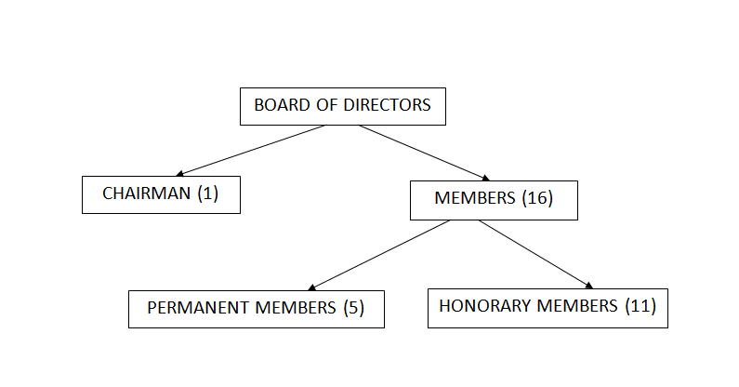

Visions of SREDA:

SREDA is a champion of sustainable energy and paves the way for an energy conscious nation to garuntee energy security and to bring down carbon emission.

Mission of SREDA:

To organize and invest in the development of green energy and energy efficiency-

* to increase the usage of renewable energy and reduce dependency on fossil fuel,
* to take fitting actions for saving energy
* to assess continuously for more potential renewable energy options

**Goals of SREDA:**

To fullfill its visions and mission, SREDA sets the following goals -

* Increase Renewable Energy generation
* Increase the proportion /amount of energy saving

.

**Objectives of SREDA:**

To achieve the goals, the objectives are-

* By the year 2020 10% (2000 MW) of the total power generation will be composed of renewable energy.
* By the year 2021 the energy saving will be 15% and 20% by 2030 of total energy consumption.

Organogram



**Organizational Structure of SREDA:**

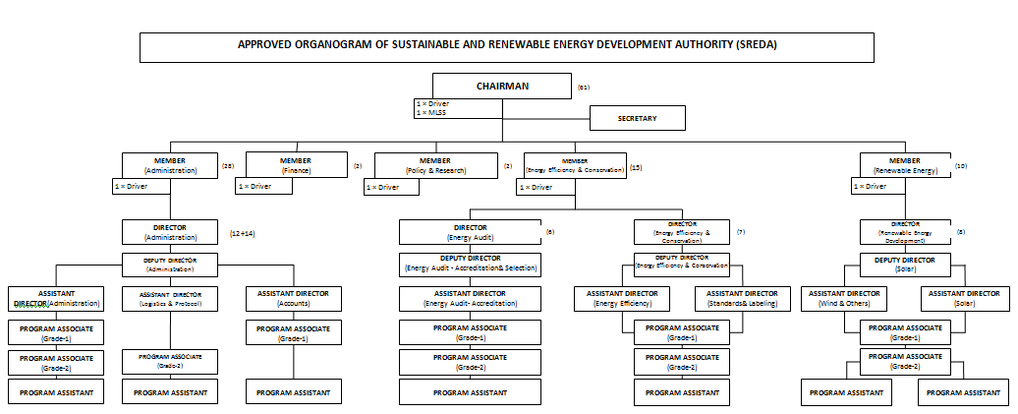

Background of Infrastructure Development Company Limited (IDCOL) :



Infrastructure Development Company Limited (IDCOL), established on 14 May 1997 by the Government of Bangladesh. Bangladesh Bank licensed the company as a non-bank financial institution (NBFI) on 5 January 1998. Since its creation, IDCOL has been a major contender in bridging the financing gap for developing medium to large-scale infrastructure and renewable energy projects in the country. It is the current market leader in private sector energy and infrastructure financing in Bangladesh.   
  
an eight-member independent Board of Directors comprising four senior government officials, three representatives from the private sector and a full time Executive Director and Chief Executive Officer manages IDCOL. It has a small and multi-skilled work force comprising financial and market analysts, engineers, lawyers, IT experts, accountants and environmental and social safeguard specialists. IDCOL's stakeholders consist of the government, private sector, NGOs, multilateral and bilateral institutions, academics and the people of Bangladesh at large.

Vision of IDCOL:

To help ensure economic growth of the country and enrich the living standard of the inhabitants through maintainable and green investments.

Mission of IDCOL:

To reinforce and enhance the private sector’s contribution in promotion, development, and financing of infrastructure as well as green energy, and energy efficient projects in a long lasting manner through public-private-partnership initiatives.

Core Values of IDCOL:

Global Standard and Competence: IDCOL is designed to deliver financial services to the clients keeping on par with global standards and competence.

Transparency and Integrity: IDCOL is a firm believer of keeping transparency and integrity in all tasks conducted by the Company.

Social Responsibility: IDCOL is inclined to play the role of a development financial institution that articulates social responsibility.

Organogram of IDCOL:

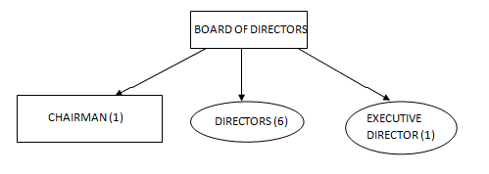

Bangladesh Infrastructure Finance Fund Limited (BIFFL) :



Background of Bangladesh Infrastructure Finance Fund Limited (BIFFL) :

Bangladesh Infrastructure Finance Fund Limited (BIFFL) is the largest Governmentowned Non-Banking Financial Institution in Bangladesh which has authorized capital and paid up capital of BDT 100 billion and BDT 20.10 billion respectively. It addresses the importance of infrastructure growth vis-à-vis not sufficient investment in that specific sector, with a foresight to raise awareness of an attractive environment for sustainable private investment.

As a portion of this, BIFFL brought to inception in 2011 as a special purpose vehicle to mobilize the PPP budget through financing infrastructure projects partnering with private sector investors.  
Moreover, to keep up sustainable development, BIFFL is also deidcated to save the environment and use economically friendly actions in all aspects which are of its utmost consideration while prioritizing any investment transaction.

## VISION of BIFFL:

Increase progression of economic efficiency by harnessing the relative merits and strengths of Public and Private Sector via financing Infrastructure Projects.

## MISSION of BIFFL:

* To act as a professional Financial Institution by implementing the globally recognized best practices and sustaining the utmost level of moral and ethical standards.
* To raise awareness of the country’s economic growth by providing and encouraging Private Sector Investment in all infrastructure projects.
* To be in support of sustainable economic growth of Bangladesh through facilitating Infrastructure Development.

## GOAL of BIFFL:

* To facilitate long-term finance to critically vital infrastructure projects.
* To accelerate co-financing from private financial sources.
* To provide a unique vehicle for capital market development by exploring a number of avenues to capture domestic and foreign investment within the contexts of a robustly designed and well-governed investment vehicle.

Organogram of BIFFL:

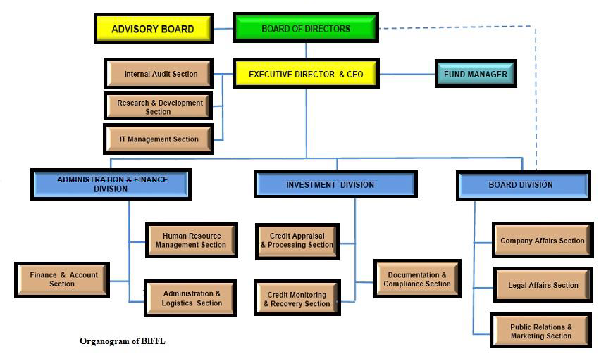

OBJECTIVE OF THE PROJECT

The main objectives of the project are given below:

• To store and manage the progress of the project in the MIS.

• To record energy consumption and production related information in the MIS.

• To maintain the consistency and integrity of data.

* To speed up the collecting processes, and ensure data safety by using cheap encrypted secure online storage (DropBox) to allow data uploads.

• To automate the loan to process it efficiently.

• To reduce manual data entry.

* Ensure cleaner data by using software to check for and report errors in several phases.

• To reduce paperwork.

* Make the site more intuitive and add a chat bot to the site so as to make it more user friendly and ensure thorough information exchange from both sides.

• To speed up the loan process by processing in parallel.

* To speed up the meeting processes by using an online chat interface to conduct meetings between in-organization stakeholders and specific meetings with off-organization stakeholders.

• To avoid processing duplicate application.

* Making sure to keep a human level checking mechanism in the vital processes.

• Not storing sensitive data or personal information locally to avoid any casualties regarding security.

* Use artificial intellegence to get intuition from data and past data of the proponents so as to help make more conclusive descisions.

Overall the main objective of the project is to propose and design a system where the stakeholders can get information, communicate with each other, make intuitive and solid descisions, get access and store information about the loan projects efficiently, and the data will be processed and handled finely to produce clean and validated data, without the risk of data loss and security casualty.

SCOPE OF THE PROJECT

In this section, we will describe the objectives of the project thoroughly for a clearer understanding of the project. Four main users have been identified in this system. Sub-project proponents, IFI, SREDA, PD. We will zoom in on the activities they can do throughout this system in form of objectives.

Online form & Contact details:

Sub-project proponents and PDs can view the pre-screening application forms, technical pre screening application forms. They can also fill up all the forms online, where forms will have computerized validators to ensure the data is clean. They will also have a chat bot on the site to make sure all the details and information publicly available on the site can be provided in an intuitive user friendly manner so as to avoid data loss. And the chat bot can accept and handle general queries and forward the queries requiring more expert support. They will have access to all vital information both via chat and the website.

Checklists, annexes, documents, instruction manuals:

All fixed documents, checklists, annexes, and instruction files will be avialable as a softcopy both downloadable and live-viewable on the website. Those which need to be inputted data can be done online and tracked via appropriate parties.

File uploads:

Documents and files can be uploaded online to a secure and cost friendly web server (Drop Box) which will ensure greater security with documents and less paper to be managed and handled.

Name clearance:

Name clearance evaluation and the registration for the clients will be tracked by both IFI & SREDA. This will ensure no data loss, better evaluation, efficient for decision making and keeping better track for the progression of the cases.

Equipment List:

Sub-project proponents and PDs can go through the list for eligible Energy efficient equipment list for their conveinience before applying for loans

Eligibility Check list:

Eligibility check list for the loans will be saved in the system for more accurate analysis by the IFIs and SREDA.

Notifying Rejection/Acceptance of Loan:

This system will enable the IFI and SREDA to make their decision and the software will automatically notify the clients of their rejection/acceptance of their cases via email and SMS. And if the case is rejected it will also let the client know the reason for rejection. Premade templates for the email and SMS will be filled with the IFI and SREDA’s feedback. The clients will be asked to verify they received the notice via logging in to their account.

Activities of IFI Employee/Manager/B.O.D:

This system will have separate secure accounts and privilages for managers, employees and Board of directors of IFI to evaluate, save results and notify the rejection/acceptance of the loan cases.

Activities of SREDA Employee/Manager/B.O.D:

SREDA employees, B.O.D will also be able to monitor the processing of the loan cases and track the projects for which loan has been granted, it can also save and modify reports.

Templating and Notifying System:

Premade templates will be available, which will be filled based on the in-organization user’s inputs on the site. This will be rendered as email and SMS and sent to those in concern. Labourious tasks like reminding, informing and requesting will be automated using this part of the system.

Chat interface:

Meetings and communication can be conducted online via the chat interface (supporting both text, voice, and video chats, and window and file sharing). This will speeden up the setup time taken to conduct in-person meetings, and can be recorded and copies will be send to stakeholders to be reviewed in the situation some information needs reclarifying.

Artificilal intellegence:

Artificially intellegenct software will be fed past data gathered on the clients and will generate predictions based on them to help those in concern be more confident in their descisions.

EXISTING BUSINESS SYSTEM WITH RICH PICTURE

EXISTING PROCESSES ALONG WITH SIX SYSTEM ELEMENTS (LOAN TYPE A)

EXISTING PROBLEMS & ANALYSIS OF THE PROBLEM ALONG WITH SOLUTION (LOAN TYPE A)

EXISTING PROCESSES ALONG WITH SIX SYSTEM ELEMENTS (LOAN TYPE B)

EXISTING PROBLEMS & ANALYSIS OF THE PROBLEM ALONG WITH SOLUTION (LOAN TYPE B)

PROPOSED BUSINESS SYSTEM WITH RICH PICTURE

PROPOSED SYSTEM RICH PICTURE DESCRIPTION (LOAN TYPE A)

PROPOSED PROCESSES ALONG WITH SIX SYSTEM ELEMENTS (LOAN A)

EXISTING PROBLEMS & ANALYSIS OF THE PROBLEM ALONG WITH SOLUTION (LOAN TYPE A)

PROPOSED PROCESS RICH PICTURE WITH DESCRIPTION ( LOAN TYPE B)

PROPOSED PROCESSES ALONG WITH SIX SYSTEM ELEMENTS (LOAN B)

EXISTING PROBLEMS & ANALYSIS OF THE PROBLEM ALONG WITH SOLUTION (LOAN TYPE B)

LOAN TYPE A ERD

LOAN TYPE B ERD